**WipeableFlatList左滑菜单**

**例:**

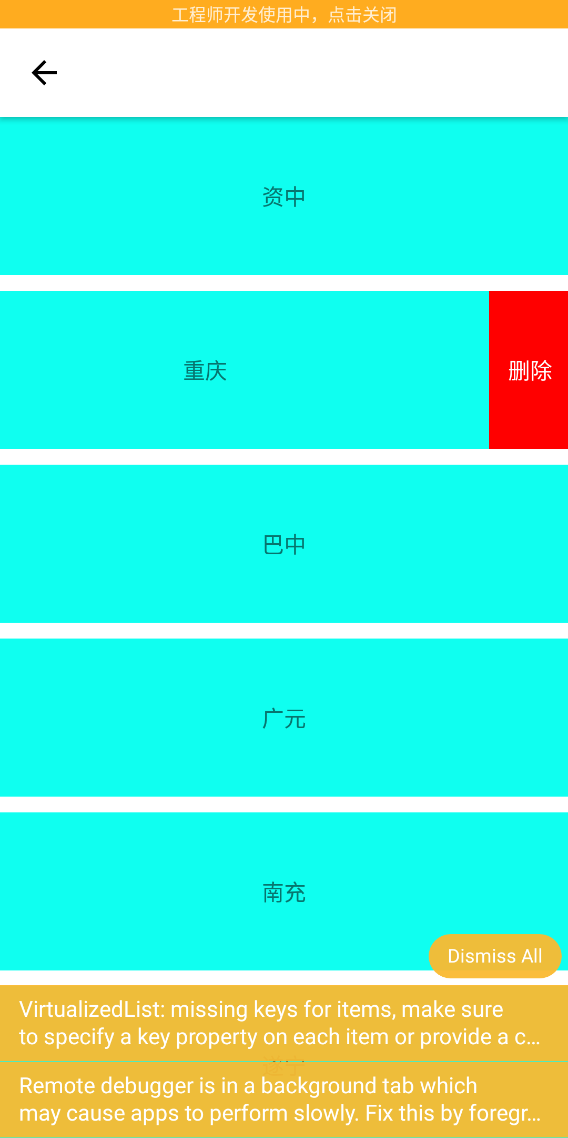

**插件名:**

**SwipeableFlatList**

**Props:**

*/**  
 * To alert the user that swiping is possible, the first row can bounce on component mount.*

*\* 是否提醒用户可以进行滑动  
 */*bounceFirstRowOnMount: boolean,  
  
*/**  
 * Maximum distance to open to after a swipe*

*\* 滑动保留的宽度  
 */*maxSwipeDistance: number | (Object => number),  
  
*/**  
 * Callback method to render the view that will be unveiled on swipe*

*\* 回调一个在互动时显示的视图*

*\*/*renderQuickActions: renderItemType,

**示例:**

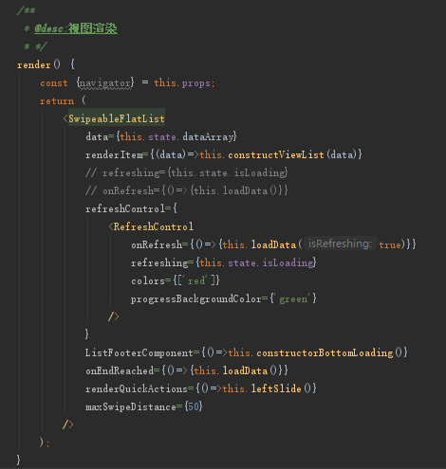

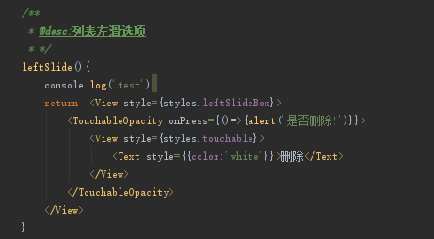

**样式:**

